Activity 1 -Joins

Exercise 1

SELECT

first_name,

last_name,

employees.department_id,

departments.department_id,

department_name

FROM

employees

INNER JOIN

departments ON departments.department_id = employees.department_id;

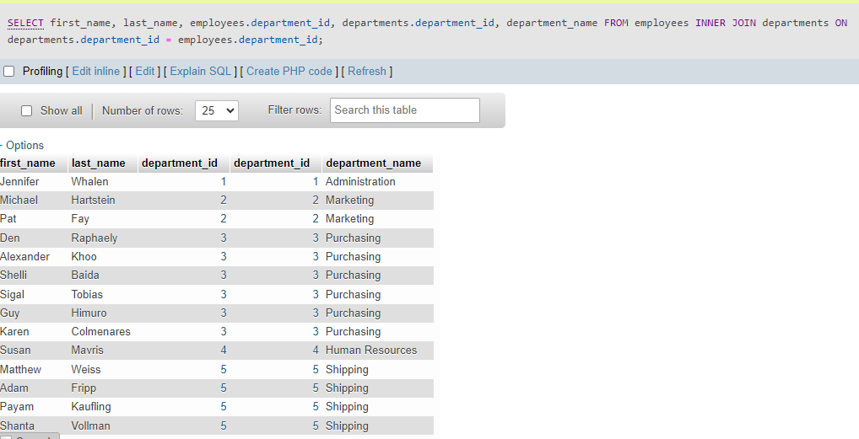

Total number of records: 40

Exercise 2

SELECT

location_id,

postal_code,

c.country_id,

country_name

FROM

locations l

INNER JOIN countries c ON c.country_id = l.country_id

ORDER BY

location_id;

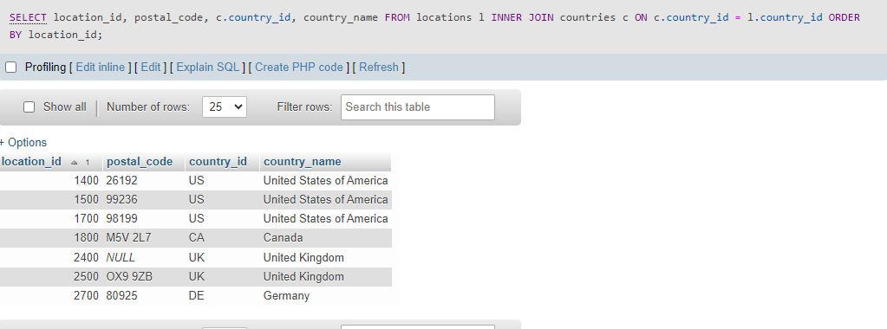

Total number of records: 7

Exercise 3

SELECT

e.employee_id,

e.first_name AS 'Employee First Name',

e.last_name AS 'Employee Last Name',

d.first_name AS 'Dependent First Name',

d.last_name AS 'Dependent Employee First Name',

d.dependent_id

FROM

employees e

LEFT JOIN dependents d ON d.employee_id = e.employee_id;

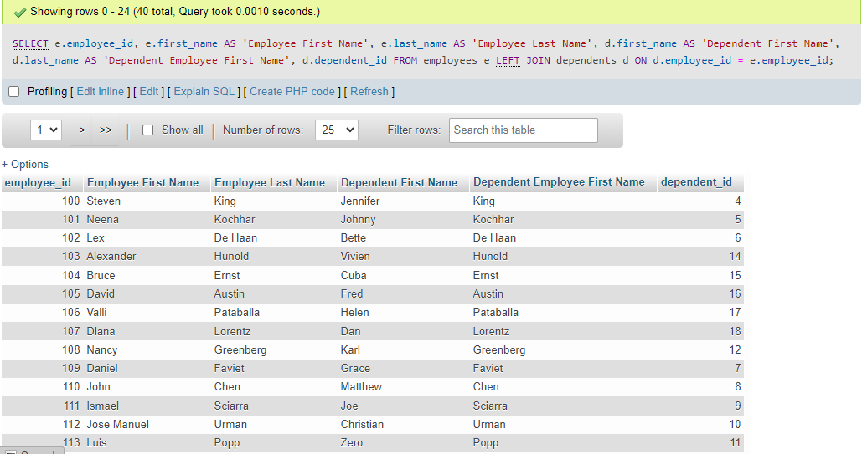

Total number of records: 40